LAB # 09
Working with JavaScript Popup boxes

Introduction
JavaScript has three kinds of popup boxes: Alert box, Confirm box, and Prompt box. We are going to emphasize the Alert and Prompt boxes.

ALERT BOX
An alert box is often used if you want to make sure information comes through to the user. When an alert box pops up, the user will have to click "OK" to proceed.
Syntax : window.alert("sometext");
The window.alert method can be written without the window prefix. Implement the code below on your notepad.
EXAMPLE 1
<!DOCTYPE html>
<html>
<head>
<script>
function myFunction()
{
alert("I am an alert box!");
}
</script>
</head>
<body>

<input type="button" onclick="myFunction()" value="Show alert box">
</body>
</html>
PROMPT BOX
A prompt box is often used if you want the user to input a value before entering a page. When a prompt box pops up, the user will have to click either "OK" or "Cancel" to proceed after entering an input value. If the user clicks "OK" the box returns the input value. If the user clicks "Cancel" the box returns null.
Syntax
window.prompt("sometext","defaultvalue");
The window.prompt() method can be written without the window prefix.
EXAMPLE 2
var name=prompt("Please enter your name","Harry Potter");
if (name!=null && name!="")
{
document.write("Hello " + name + "! How are you today?");
}
EXAMPLE 3

<!DOCTYPE html>
<html>
<head>
<script>
function myFunction() {
document.getElementById("demo").innerHTML = "Hello World";
}
</script>
</head>
<body>

<p>Click the button to trigger a function.</p>

<button onclick="myFunction()">Click me</button>

<p id="demo"></p>

</body>
</html>
Output:
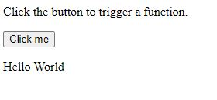
EXAMPLE 4
<!DOCTYPE html>
<html>
<head>
<script>
const number1 = parseFloat(prompt('Enter first number: '));
const number2 = parseFloat(prompt('Enter second number: '));
let result;
result = number1 + number2;
// display the result
document.write("Final output is :" +result);
</script>
</head>
<body>
</body>
</html>

Lab Tasks
Task #01: Create a temperature converter using JavaScript. Then apply a formula to convert Fahrenheit to Celsius.
Formula:
- Celsius = (Fahrenheit -32) * 5 / 9;

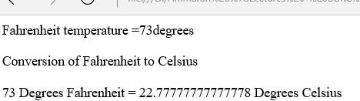

Task # 02: Take two inputs from the user using the prompt box. Ask the user to choose any one of the following operations.
- addition
- subtraction
- multiplication
- division
The final result should look like this:
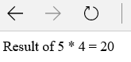

Hint (Convert String to Int ) :
var val1= prompt("Enter the Value of a : ", 0);
var val2= prompt("Enter the Value of b : ", 0);
var a=parseInt(val1);
var b=parseInt(val2);

